Baby boomers are not lonelier than previous generations, researchers find
By Susan Perry | 12/12/2019
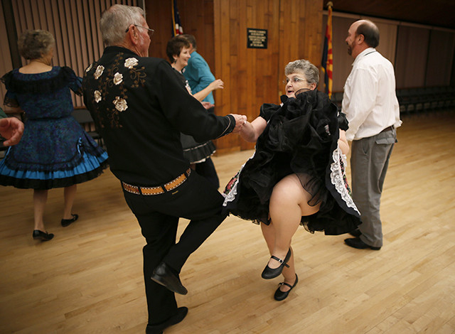
REUTERS/Lucy Nicholson
The researchers found that people reported decreasing levels of loneliness between the ages of 50 and 74. That trend reversed, however, as they passed the age of 75.
Despite all the headlines claiming that aging baby boomers have become “the loneliest generation” in history, older people today are not any lonelier than their counterparts were in previous generations, according to two studies published this week in the journal Psychology and Aging.
In fact, they might even be a little bit less lonely.
“We found no evidence that older adults have become any lonelier than those of a similar age were a decade before,” says Louise Hawkley, the lead author of one of the studies and a senior research scientist at NORC at the University of Chicago, in a released statement. “However, average reported loneliness begins to increase beyond age 75, and therefore, the total number of older adults who are lonely may increase once the baby boomers reach their late 70s and 80s.”
The belief that people are lonelier today than in the past appears to be based, at least in part, on a misunderstanding of what loneliness is. It’s true that a larger proportion of people now live alone. It’s also true that a smaller proportion of people are engaged in civic activities. But these trends do not necessarily mean that more people are lonely.
“Loneliness is not synonymous with structural indicators of social connection but is instead defined by a perceived discrepancy between desired and attained social relationships,” Hawley and her co-authors write in their paper. “Thus, structural changes in society may not necessarily yield changes in loneliness prevalence or intensity.”
As Hawkley explained to ABC News: “People can feel lonely even if surrounded by others, and people do not necessarily feel lonely even if they are alone.”
Still, loneliness is a significant health concern — and will become increasingly so for baby boomers as they continue to age. People who feel lonely and socially isolated are at higher risk for a variety of physical and mental conditions, including heart disease, a weakened immune system, depression, cognitive decline, and even death.
The American study
For their study, Hawkley and her colleagues analyzed data from three U.S. national surveys of more than 8,000 older adults born between 1920 and 1965. The first survey was taken in 2005-2006, and the last was done a decade later, in 2015-2016. Among the questions asked on the survey were ones designed to assess feelings of loneliness.
The researchers found that people reported decreasing levels of loneliness between the ages of 50 and 74. That trend reversed, however, as they passed the age of 75.
Yet there was no evidence that this pattern was any different for baby boomers than it was for people of older generations.
The increase in loneliness after age 75 is likely the result of declining health and the loss of social relationships, particularly the death of a spouse or partner, the study also found.
“Our research suggests that older adults who remain in good health or maintain social relationships with a spouse, family or friends tend to be less lonely,” says Hawkley.
“Video chatting platforms and the Internet may help preserve their social relationships,” she adds. “These tools can help older adults stay mobile and engaged in their communities.”
The Dutch study
For the second study, researchers in the Netherlands analyzed survey data from almost 5,000 Dutch adults born between 1908 and 1957. The surveys, which were conducted between 1992 and 2016, asked participants to quantify their feelings of loneliness on a scale of 0 (no loneliness) to 11 (severe loneliness). They also asked questions designed to measure how much the participants’ felt in control of situations and of their life in general.
As in the American study, loneliness was found to increase after age 75. But, unlike the American study, the Dutch study also found a generational difference: People in the study’s later-born generations were less likely to report being lonely than those who belonged to earlier generations. The effect was small, but still statistically significant.
The researchers believe that older people in later generations may feel less lonely because they have had the resources and opportunities to be more in control of their lives.
“In contrast to assuming a loneliness epidemic exists, we found that older adults who felt more in control and therefore managed certain aspects of their lives well, such as maintaining a positive attitude, and set goals, such as going to the gym, were less lonely,” explains Bianca Suanet, the study’s lead author and a professor of sociology at Vrije Universiteit Amsterdam, in a released statement. “Additionally, as is well-known in loneliness research, participants who had a significant other and/or larger and more diverse networks were also less lonely.”
Suanet says efforts to decrease loneliness should focus on helping older people feel more in control of their lives rather than only on giving them greater access to social activities.
“People must manage their social lives better today than ever before because traditional communities, which provided social outlets, such as neighborhoods, churches and extended families, have lost strength in recent decades,” she explains. “Therefore, older adults today need to develop problem-solving and goal-setting skills to sustain satisfying relationships and to reduce loneliness.”
FMI: You’ll find both articles on Psychology and Aging’s website.

