A Loneliness Epidemic? One-Third of Older Adults Report Being Lonely
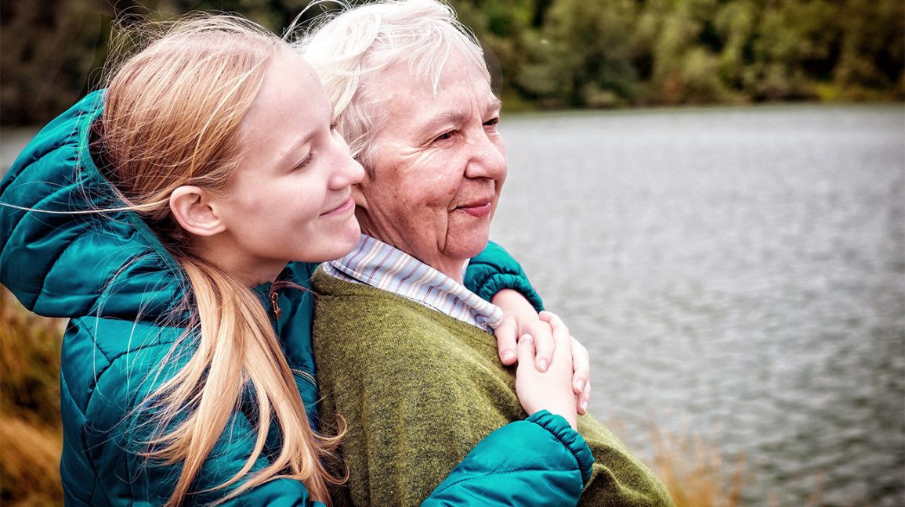Share on Pinterest
People in their late 70’s report increasing feelings of loneliness. Getty Images
As adults reach their late 70s and 80s, they report increasing rates of loneliness.
That isn’t necessarily an increase from previous generations, but experts say it can still be damaging.
To stave off loneliness, experts recommend taking steps like volunteering.
Americans are increasingly reporting feelings of loneliness. Experts say it may have something to do with aging, according to research recently published by the American Psychological Association.
However, experts say it may not be that current generations are more lonely than previous ones.
In one study, University of Chicago researchers found no evidence that older adults are lonelier than their counterparts were a decade earlier.
However, the number of lonely adults may increase once baby boomers reach their late 70s and 80s, Louise C. Hawkley, PhD, a lead author of one of the studies, said in a prepared statement.
The U.S. Census Bureau reports that approximately 10,000 baby boomers turn 65 each day, a trend that’s expected to continue through 2030.
In the other study, Dutch researchers found that to counteract loneliness, older adults living in the Netherlands who felt they had more control and were able to better manage their lives were less likely to feel lonely.
Both studies were published in the journal Psychology and Aging.
For the University of Chicago study, Hawkley and her colleagues used data from the National Social Life, Health and Aging Project and the Health and Retirement Study. Both are national surveys of older adults that compared three groups of U.S. adults born in different periods of the 20th century.
They analyzed data of thousands of adults born between 1920 and 1947 and between 1948 and 1965. They examined participants’ levels of loneliness, educational attainment, overall health, marital status, and the number of family members, relatives, and friends they felt close to.
Researchers found that loneliness decreased between the ages of 50 and 74 but increased after age 75. They also found there was no difference in loneliness between baby boomers and similar-aged adults of earlier generations.
In the other study, Bianca Suanet, PhD, of Vrije Universiteit Amsterdam, the lead author of the study, and other researchers used data from the Longitudinal Aging Study Amsterdam, which is a long-term study of the social, physical, cognitive, and emotional functioning of 4,880 older adults born between 1908 and 1957.
The study measured peoples’ loneliness, control over situations and life in general, and goal achievement.
Suanet said in a news release that she and her researchers found that older adults who felt more in control and therefore managed certain aspects of their lives well, such as maintaining a positive attitude, and set goals, such as going to the gym, were less lonely.
Tracey Gendron, an associate professor and chair of the gerontology department at Virginia Commonwealth University, says the studies confirm what’s been known over the past decade.
Trends of loneliness among adults have maintained in the last decade “and are going up because the population of older adults is going up,” Gendron said in an interview.
But John Piette, a professor of global public health and internal medicine at the University of Michigan, says that while it may be true that older adults may not be lonelier, it’s important to remember that about 30 percent of older adults are still lonely.
He calls loneliness a toxic situation, noting that lonely adults are more likely to die earlier and are more susceptible to substance use and dementia.
Keeping loneliness at bay
Festive periods like Christmas and Thanksgiving in particular can exacerbate loneliness among older adults due to the increased number of social gatherings — or the perception of a great time being had by seemingly everyone else — during that period, experts say.
Loneliness in late life is driven by several factors and changing social trends, such as an increase in the rate of divorce in mid-to-late life, the loss of a spouse or close friend, and the increase of chronic illness with age.
“Older adults with better health are more likely to maintain social relationships,” Ruth Walker, an assistant professor in the department of psychology at Missouri State University, said by email.
Experts say older adults can take several steps to combat loneliness by volunteering and connecting with other older adults through social, religious, and even political organizations.
“Research on the benefits of volunteering has shown that older adult volunteers have improved social support, self-esteem, life satisfaction, and lower mortality rates,” Walker said.
Volunteering can have immense health benefits, adds Piette.
“It is amazingly therapeutic for people,” he said in an interview. “Volunteering can combat a sense of loss of purpose and a lack of cognitive stimulation. Getting out there and volunteering and helping, getting involved in church and being helpful to others are some of the best things you can do.”
Experts also say that technology, such as mobile phones and other devices, can play a role in combating loneliness.
Lisa Hall, an associate professor in the department of psychology at Missouri State University, says these devices can provide some distraction and provide a feeling of connectedness.
“Online video chatting has the greatest promise, over texting and social media,” she said by email.
“However, it is contingent upon the older adult being aware of and comfortable with using the technology. Many devices are not readily vision-, hearing-, and arthritis- friendly (small buttons, small screens, tiny flip switches),” Hall said.

